HW1
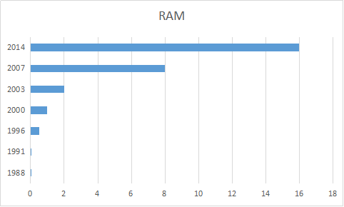
The memory of PCs over the last 30 years keep increasing all the time. In the initial years, it rise slowly, but after 2003, it increases explosively.
2.
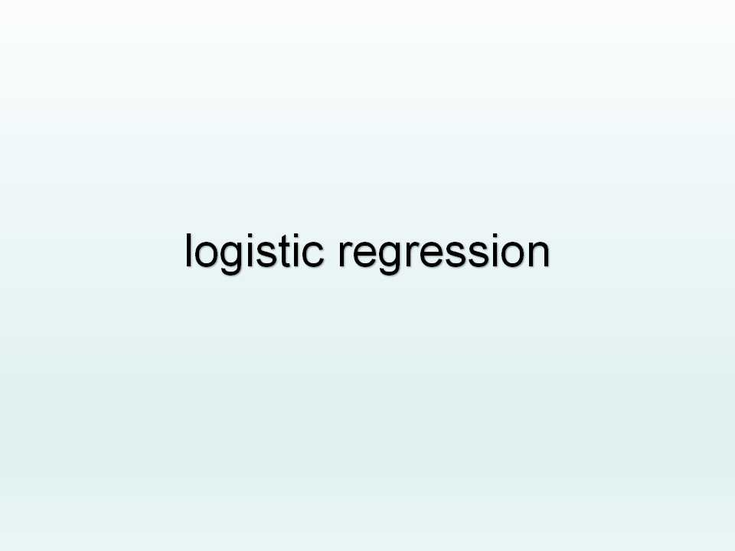
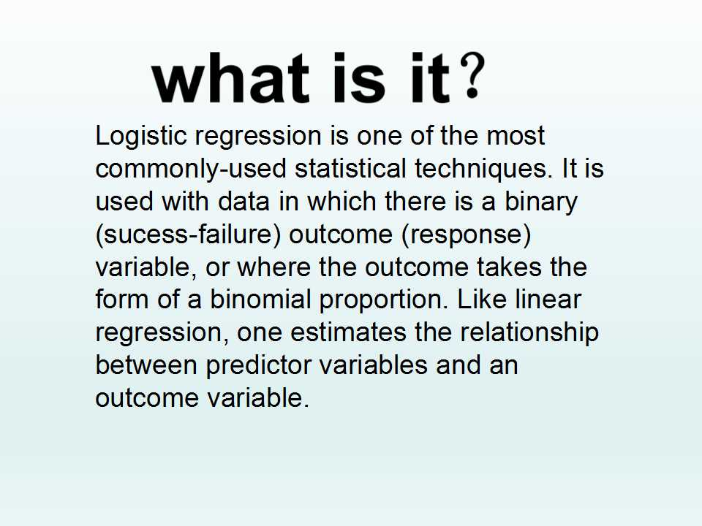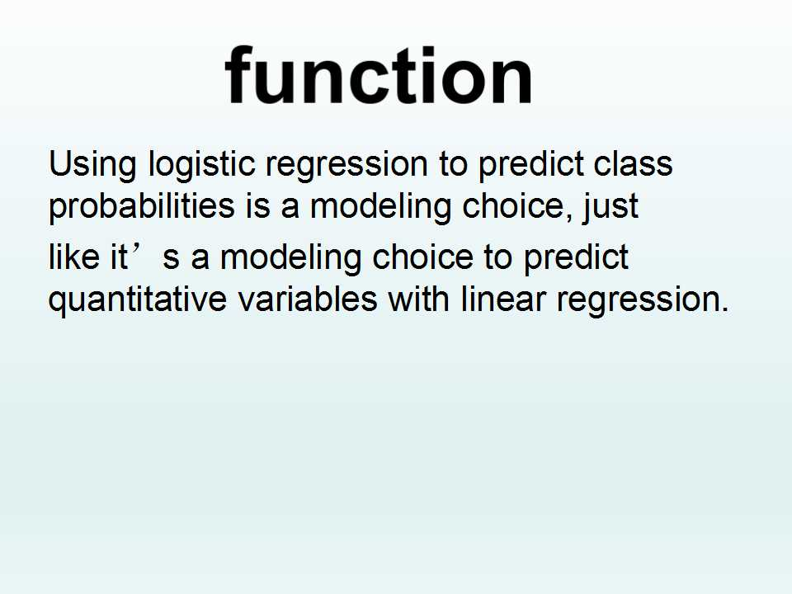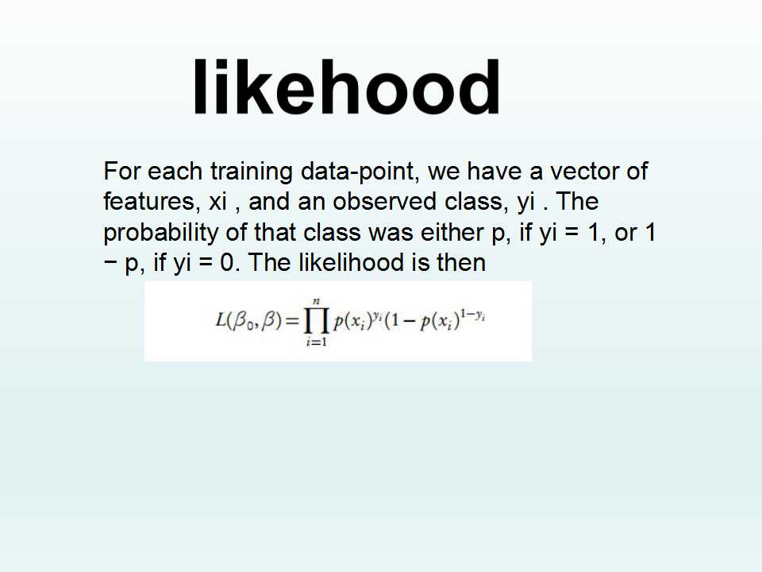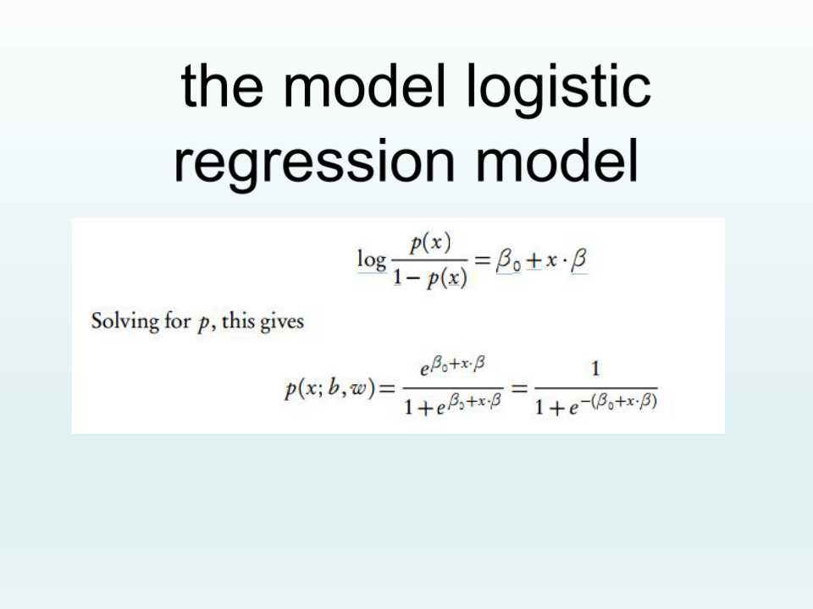
HW2
data<-read.table("C:/Users/yyy/Desktop/hw1.csv",header=TRUE,sep=",")
x<-data$Year
y<-data$RAM
plot(x,y)
lines(spline(x,y))
lines(spline(x, y, n = 201), col = 2)
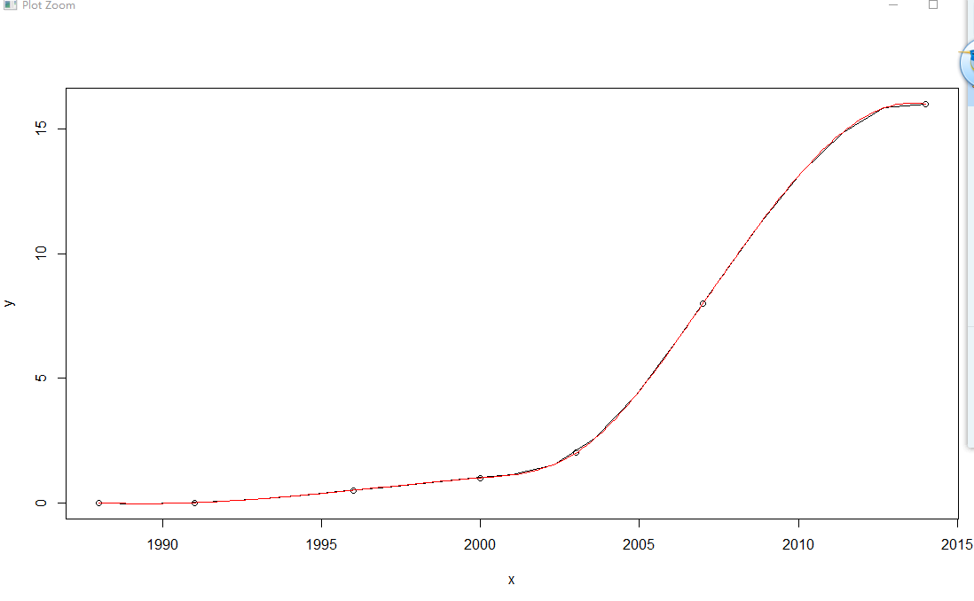
3. x = 6
n = 1000
lambda = 2
p = lambda / n
dbinom (x,2*n,p) # binomial probability mass function
dpois (x, 2*lambda ) # Poisson probability mass function
dpois (0, 5 )

HW3
1.
> install.packages('digest')
# call the library doing the hashes
library("digest")
# now do the hash code calculation
digest("I learn a lot from this class when I am proper listening to the professor")
digest("I do not learn a lot from this class when I am absent and playing on my Iphone")
> # call the library doing the hashes> library("digest")
> # now do the hash code calculation
> digest("I learn a lot from this class when I am proper listening to the professor")
- "a8d3e4701672195e5dcd16ea9b062279"
> digest("I do not learn a lot from this class when I am absent and playing on my Iphone")
- "497edecd95aca5cc9a581e4835c3cccd"
2.
2.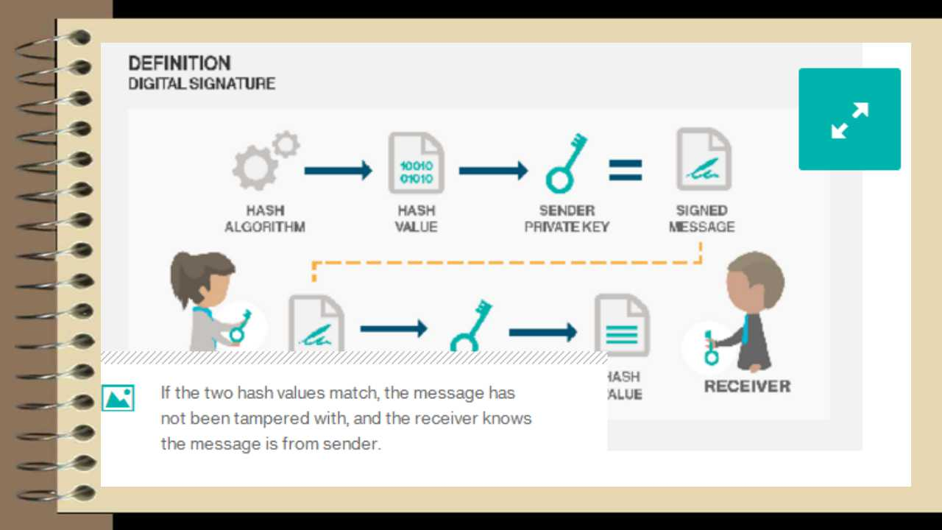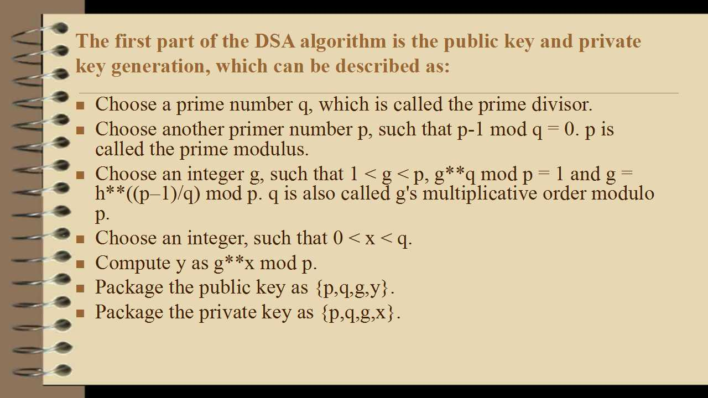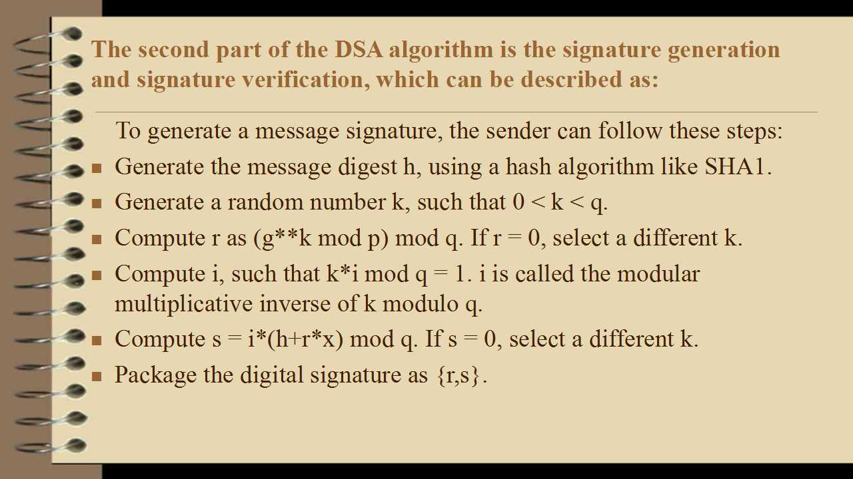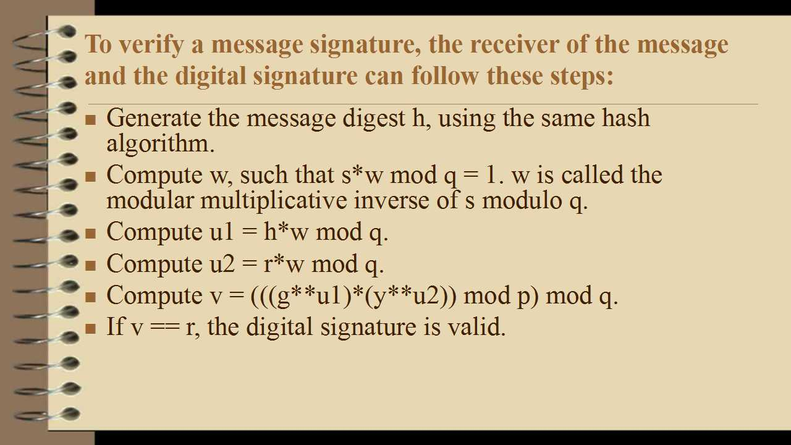
3.
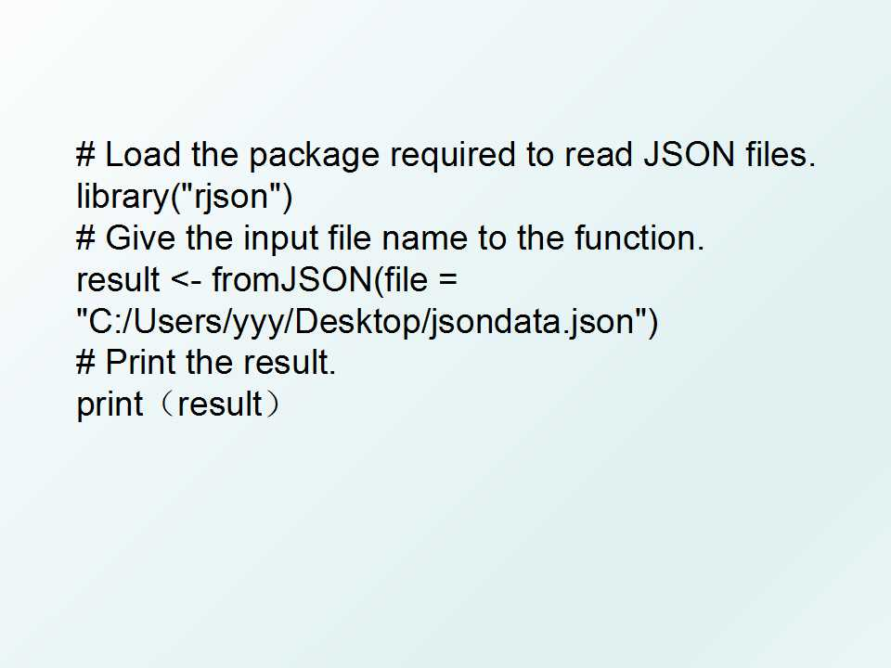

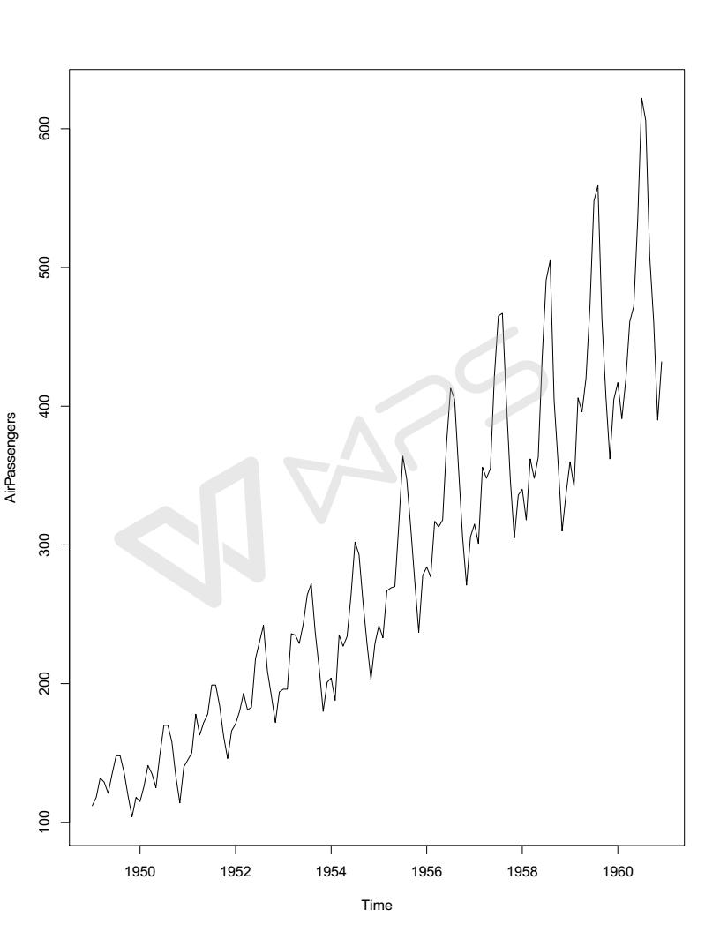
HW4
#install.packages("rjson", repos="http://cran.us.r-project.org")
library("rjson")
json_file = "http://crix.hu-berlin.de/data/crix.json"
json_data = fromJSON(file=json_file)
crix_data_frame = as.data.frame(json_data)
n=dim(crix_data_frame)
a=seq(1,n[2],2)
b=seq(2,n[2],2)
date=t(crix_data_frame[1,a])
price=t(crix_data_frame[1,b])

ts.plot(price)
ret=diff(log(price))
ts.plot(ret)

Figure4
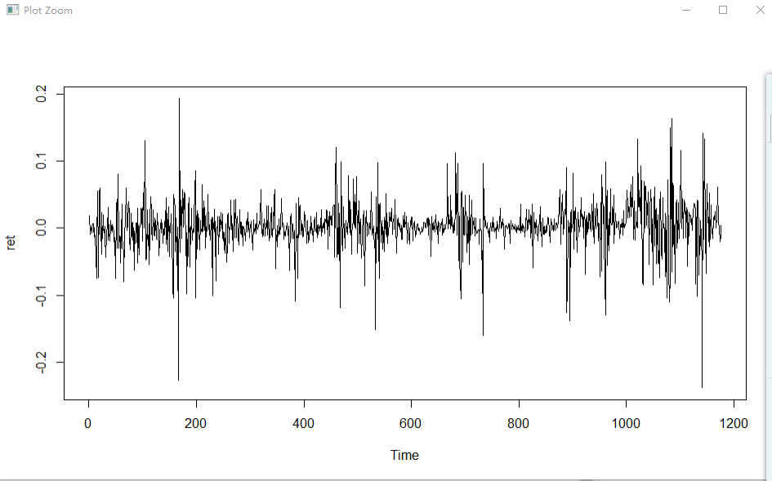

HW4
